The Lightweight IBM Cloud Garage Method for Data Science

Architectural Decisions Document Template

# Architectural Components Overview

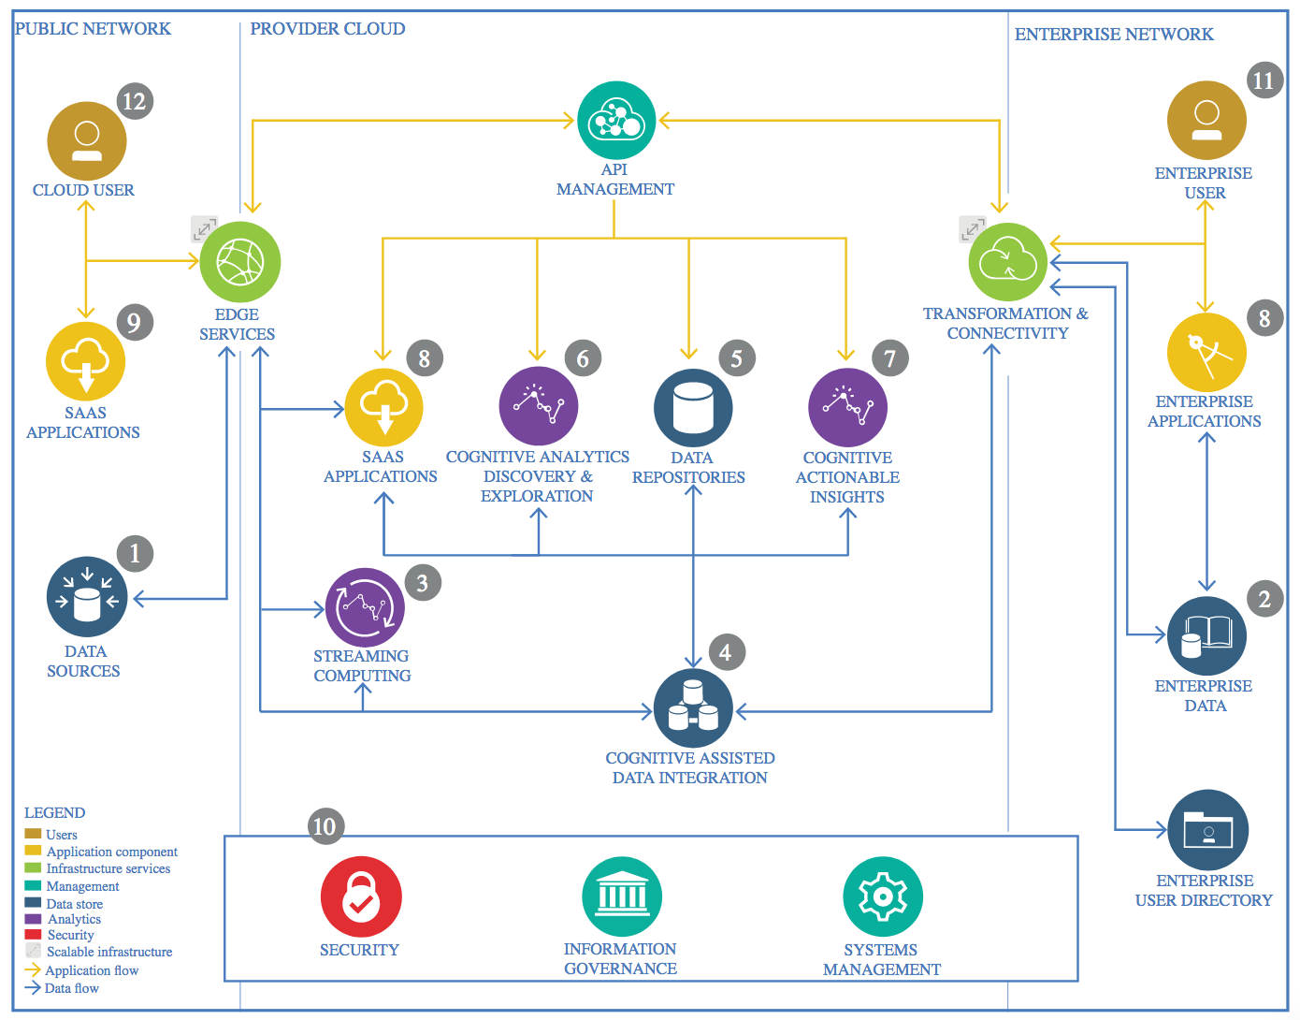

IBM Data and Analytics Reference Architecture. Source: IBM Corporation

## Data Source

### Technology Choice

Kaggle to get Dataset

### Justification

On Kaggle.com we have many datasets ready for use. So we don’t need to work too hard on the data.

## Enterprise Data

### Technology Choice

### Justification

Not needed because our data is public.

## Streaming analytics

### Technology Choice

Using IBM Watson Studio

### Justification

Using a notebook on the cloud is a faster choice, since we don’t need to install many resources in our computers.

## Data Integration

### Technology Choice

IBM Cloud

### Justification

IBM Cloud offer many resources on the cloud as well analytics straight in our data.

## Data Repository

### Technology Choice

IBM Cloud

### Justification

IBM Cloud offers many databases. NoSql database Cloudant Databse…

## Discovery and Exploration

### Technology Choice

IBM Cloud

### Justification

IBM Cloud offer many resources on the cloud as well analytics straight in our data.

## Actionable Insights

### Technology Choice

IBM Watson Studio

### Justification

We can use Jupyter notebook to demonstrate our insights from our data

## Applications / Data Products

### Technology Choice

### Justification

We are not deploying one application for this moment. Just one API

## Security, Information Governance and Systems Management

### Technology Choice

IBM Cloud

### Justification

We can use IBM Cloud to deploy our API.